 | 2024

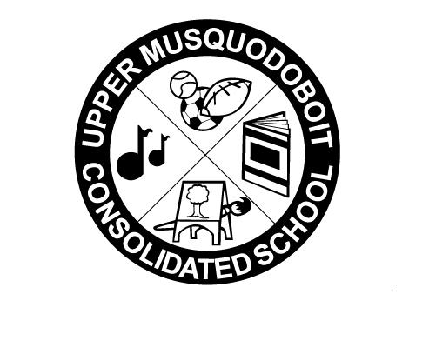
Upper Musquodoboit Consolidated School
Sunday | Monday | Tuesday | Wednesday | Thursday | Friday | Saturday
 | Phys. Ed P-6 | Music | Library | Phys. Ed. P-6 | Music
 |  | 1 | 2 | 3 | 4 Bus Evacuation | 5
 |  | Garlic Fingers | Grade 6 Provincial  Assessments  RWM6 | Grade 6 Provincial  Assessments  RWM6 |   Pepperoni Pizza | World Teacher Day
6 | 7 | 8  Fluoride Forms due | 9  PHOTO DAY  Grade 6 Assessments | 10 | 11 | 12
 |  | Garlic Fingers  Garlic Fingers | SAC meeting 2pm |  | Professional Development  No Classes  Pepperoni Pizza
13 | 14 No Classes | 15 | 16 | 17 | 18 | 19
 |  | Garlic Fingers | Grade 6 Provincial  Assessments  RWM6 |  | Tom the Tomato Plant Presentation  Pepperoni Pizza
20 | 21 | 22 | 23 | 24 | 25 | 26
 | Say the ABC’s in a spooky voice!  Tell a story that begins with “When I was little….  National Cat Day!  How many words can you rhyme with cat?  Halloween Costume Day  Pepperoni or Cheese Pizza |  |  |  | Professional Development  No Classes
27 | 28  Fluoride Clinic | 29 | 30 | 31  