|  |  |
| --- | --- |
| Related image | **2024** |

|  |
| --- |
| UMCS LOGO No WORDS **Upper Musquodoboit Consolidated School** |
|  |

|  |  |  |  |  |  |  |
| --- | --- | --- | --- | --- | --- | --- |
| **Sunday** | **Monday** | **Tuesday** | **Wednesday** | **Thursday** | **Friday** | **Saturday** |
|  | ***Phys. Ed./Fiddle*** | ***Music*** | ***Library*** | ***Phys. Ed.*** | ***Music*** |  |
| **1** | **2** | **3** | **4** | **5** | **6** | **7** |
|  | ***Report Cards***  Appointment Booking for Parent Teacher | *Garlic Fingers* | *Chicken Burgers* | ***PD-AM***  ***Parent Teacher - PM***  ***1-3/5:30-7:30***  ***No Classes*** |  |  |
| **8** | **9** | **10** | **11** | **12** | **13** | **14** |
|  |  |  |  |  | Pizza |  |
| **15** | **16** | **17** | **18** | **19** | **20** | **21** |
|  | ***Santa Hat/Reindeer Antlers*** ***12:30pm & 6:00pm*** | ***Red / Green Day***  ***Concert Snow Date*** | ***Ugly Sweater Day***  *Jingle Bell Breakfast*  ***Bazaar*** | **Plaid/Camo Day** | ***Last Day*** |  |
| **22** | ***23*** | ***24*** | ***25*** | **26** | **27** | **28** |
|  |  | **Royalty Free Clipart Image of a Santa Clause Bear Puppy in the Snow** | **Christmas Day**  Image result for present | **Royalty Free Clipart Image of a Christmas Wreath** | Penguin on skates, bird skating on ice rink, Christmas holidays celebration. Arctic cartoon character on snowy blue with snowflakes. Polar animal greeting card |  |
| **29** | **30** | **31** | **1** | **2** | **3** | **4** |
|  |  |  |  | **Christmas Break**  **Classes Resume on Friday, January 3, 2025** |  |  |

**Christmas Spirit Week**

**Monday: Wear Santa Hats/Reindeer Antlers**

***12 :30pm & 6.00pm***

**Tuesday: Red and Green Day**

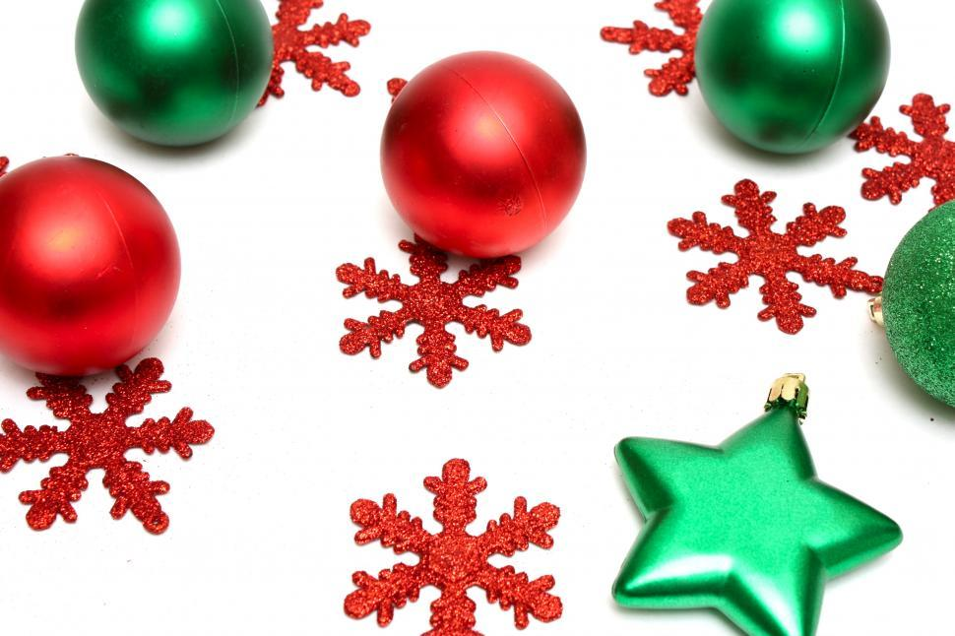

**Concert Snow Day**

**Decorate Sweaters or Shirts for Wednesday**

**Wednesday: Jingle Bell Breakfast/Bazaar**

**Ugly Christmas Sweater Day**

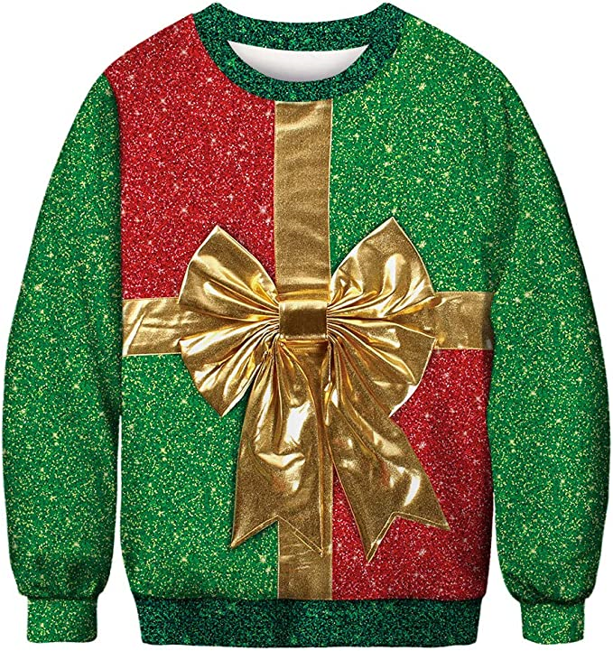

**Thursday: Plaid/Camo Day**

**Cookie Decorating**

**Friday: Pajama Day**

**Movie**