 | 2025

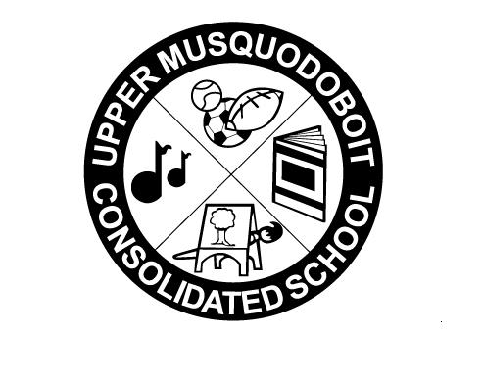
Upper Musquodoboit Consolidated School
Sunday | Monday | Tuesday | Wednesday | Thursday | Friday | Saturday
 | Phys. Ed.  Band |  | Band/Music | Phys. Ed.  Music/Fiddle | Library
 |  |  | 1 Treaty Day | 2 | 3 | 4
 | 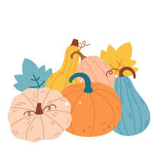 |  | Fluoride Program Begins |  | Bus Evacuation  
5 | 6 | 7 | 8 | 9 | 10 | 11
 |  | GR. 6 Assessments | Sac Meeting  2pm  GR. 6 Assessments |  | 
12 | 13  No Classes | 14 | 15 | 16 | 17 | 18
 |  |  | GR. 6 Assessments | School Picture Day  GR. 6 Assessments | 
19 | 20 | 21 | 22 | 23 | 24 | 25
 | Say the ABC’s in a spooky voice!  Tell a story that begins with “When I was little….  National Cat Day!  How many words can you rhyme with cat?  Halloween Costume Day  Pepperoni or Cheese Pizza |  |  |  | Conference Day  No Classes
26 | 27  M’IKMAQ | 28  HISTORY | 29  MONTH | 30 | 31 

