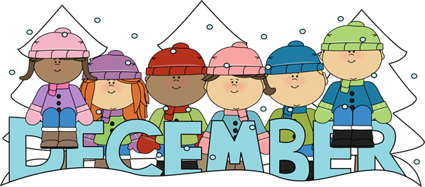 | 2025


Upper Musquodoboit Consolidated School
Sunday | Monday | Tuesday | Wednesday | Thursday | Friday | Saturday
 | Phys. Ed./Band |  | Band/Music | Music/Fiddle/Phys. Ed. | Library
 | 1 | 2 | 3 | 4 | 5 | 6
 | Appointment Booking for Parent Teacher | Garlic Fingers | Chicken Burgers | PD-AM  Parent Teacher – PM  1-3pm & 5:30-7:30pm  No Classes |  | Christmas at the EX  10am-2pm
7 | 8 | 9 | 10 | 11 | 12 | 13
 |  |  |  |  | Pizza
14 | 15 | 16 | 17 | 18 | 19 | 20
 |   Twin Day |   12:30 Dress Rehearsal  6pm Concert  Red & Green Day | Jingle Bell Breakfast  Bazaar  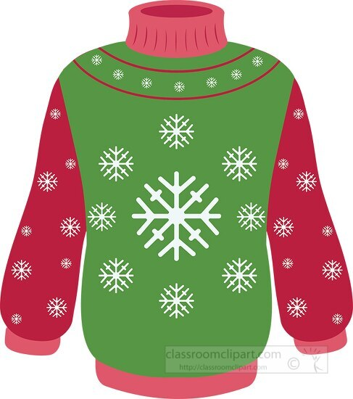  Xmas Sweater Day | Concert Snow Date  Santa Hat/Reindeer Antlers Day | Last Day  For Students  
21 | 22 | 23 | 24 | 25 | 26 | 27
 |  |  |  | Christmas Day   | 
28 | 29 | 30 | 31 | 1 | 2 | 3
Christmas Break
Classes Resume on Monday, January 5, 2026

