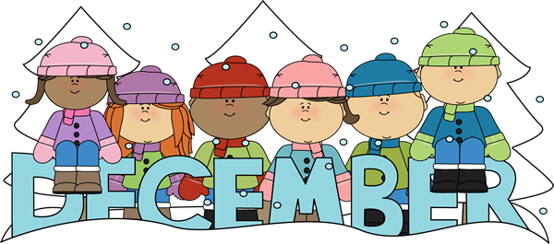 | 2022

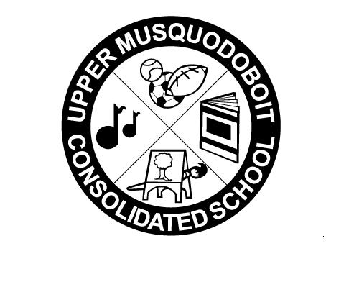
Upper Musquodoboit Consolidated School
Sunday | Monday | Tuesday | Wednesday | Thursday | Friday | Saturday
 | Phys. Ed. P-6 | Music/Fiddle Phys.Ed 3-4 | Library | Phys. Ed. P-6 | Music
 |  |  |  | 1 | 2 | 3
 |  | Garlic Fingers | Chicken Burgers | PD-AM  Parent Teacher - PM  1-3/6-8  No Classes | PD Day  No Classes  Pizza
4 | 5 | 6 | 7 | 8 | 9 | 10
 |  | Garlic Fingers | Reindeer  Sloppy Joes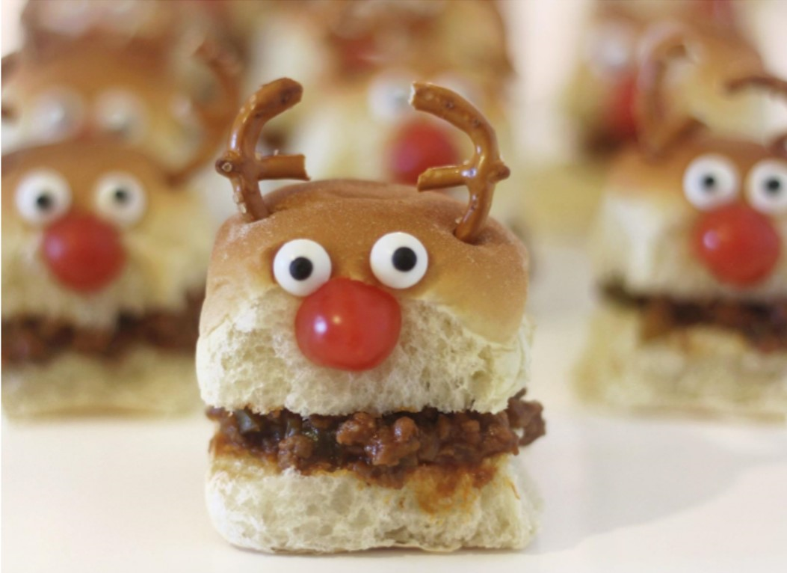py Joes |  | Pizza  Pizza
11 | 12 | 13 | 14 | 15 | 16 | 17
 | Crazy Hair/Hat Day  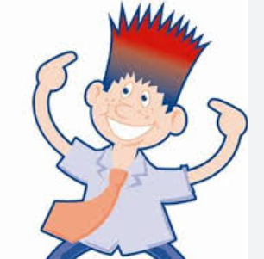 | Christmas Concert  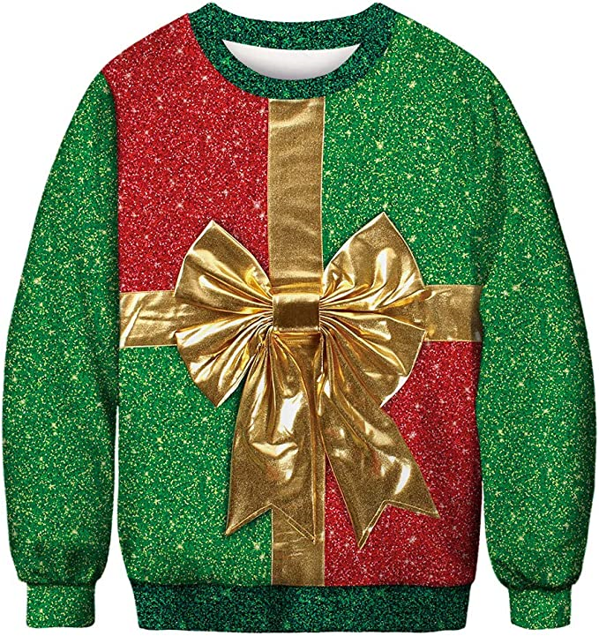  ChristmasSpirit/Ugly Sweater Day Garlic Fingers | Red/Green Day  Turkey Dinner  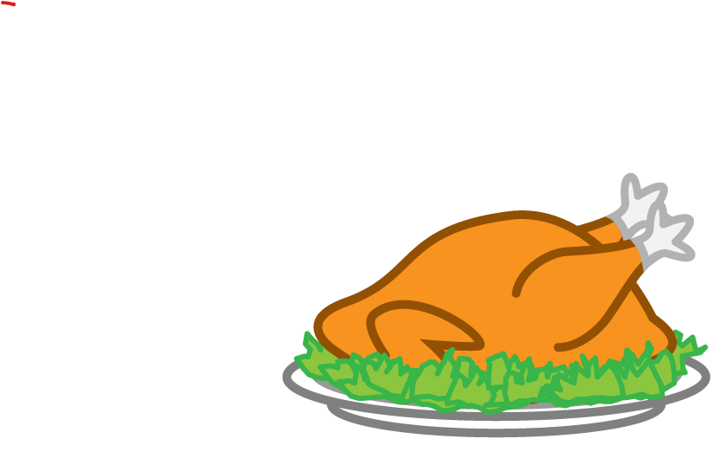 | Plaid/Camo Day  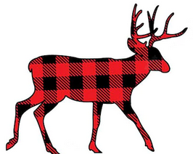 | Twin Day  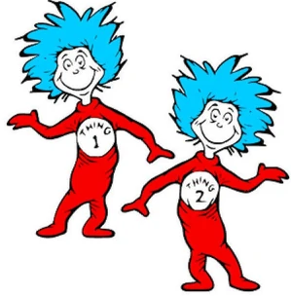Pizza  Pizza
18 | 19 | 20 | 21 | 22 | 23 | 24
 |  | Garlic Fingers  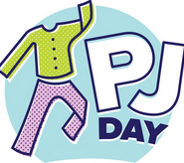  Garlic Fingers |  | Christmas Break
25 | 26 | 27 | 28 | 29 | 30 | 31
Christmas  Day |  |  | Christmas Break  Classes Resume on Tuesday, January 3, 2023
Christmas Spirit Week

Monday: Crazy Hair/Hat Day

Tuesday: Christmas Spirit / Ugly Sweater Day

Wednesday: Red and Green Day

Thursday: Plaid/Camo Day

Friday: Twin Day

Tuesday December 21: Pyjama Day

