2023

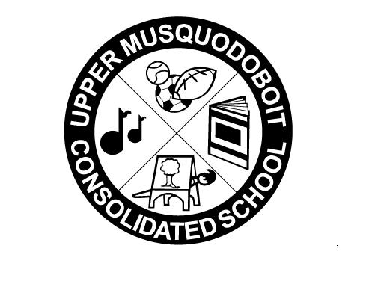
Upper Musquodoboit Consolidated School
Sunday | Monday  Phys. Ed.  P-6 | Tuesday  Music  Phys. Ed. 3-4 | Wednesday  Library | Thursday  Phys. Ed.  P-6 | Friday  Music | Saturday
 |  |  | 1 | 2 | 3 | 4
 |  |  | Chicken Caesar Wrap |  | Pizza
5 | 6 | 7 | 8 | 9 | 10 | 11
 |  | Jersey Day  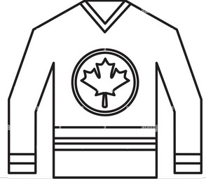  Garlic Fingers  Garlic Fingers | 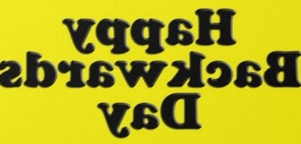  Alfredo Pasta/Garlic Toast | 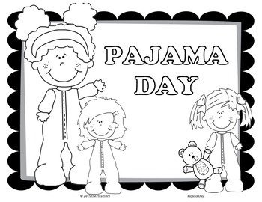 | Green Day  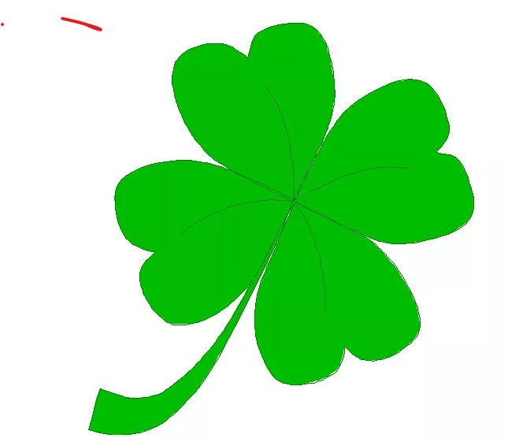  Pizza  Pizza
12 | 13 March | 14 Break | 15 No Classes | 16 March | 17 Break | 18
19 | 20 | 21 | 22 | 23 | 24 | 25
 | Assessment & Evaluation Day  No Students Present | Garlic Fingers | Tacos |  | Pizza
26 | 27 | 28  SAC Meeting- 2pm  Report Cards  Go Home  Garlic Fingers | 29  Chicken Pot Pie | 30  AM – PD day  PM – Parent Teacher  No Classes | 31  Pizza

