2023

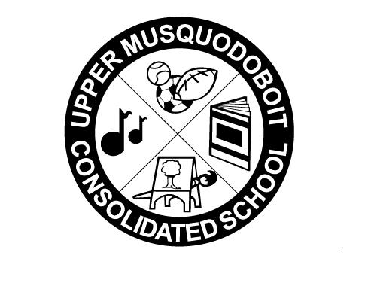
Upper Musquodoboit Consolidated School
Sunday | Monday  Phys. Ed.  P-6 | Tuesday  Music/Fiddle  Phys. Ed. 3-4 | Wednesday  Library | Thursday  Phys. Ed.  P-6 | Friday  Music | Saturday
 | 1 | 2 | 3 | 4 | 5 | 6
 |  | Garlic Fingers | Ham & Cheese Sliders | Star Wars Day | Pizza | Coronation of King Charles lll  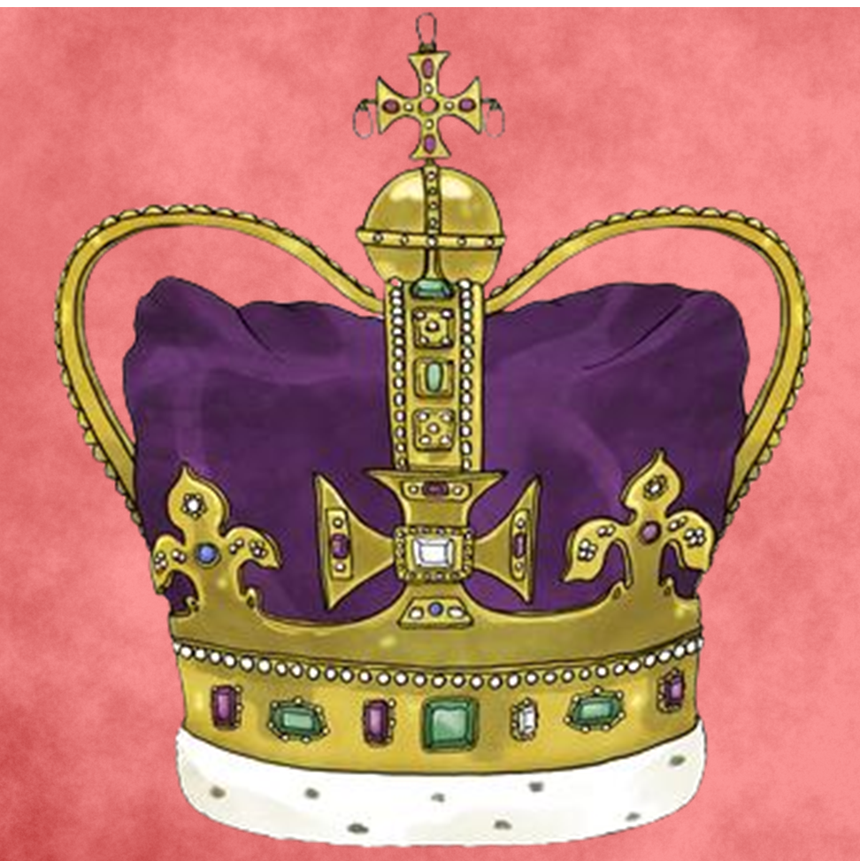
7 | 8 | 9 | 10 | 11 | 12 | 13
 | No Socks Day  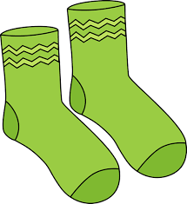 | Lost Sock Memorial Day  Garlic Fingers | Clean Up Your Room Day  Pancakes |  | Pizza
14 | 15 | 16 | 17 | 18 | 19 | 20
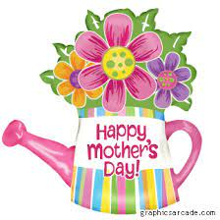 | Grade 3 Literacy Assessment | Garlic Fingers | Grade 6 MRHS  Orientation -pm  Chicken Burgers  Grade 3 Literacy Assessment  Chicken Burgers |  | Grade 3 Math Assessment  Pizza
21 | 22 | 23 | 24 | 25 | 26 | 27
 | No Classes  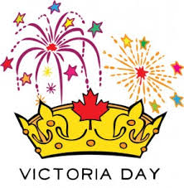 | Grade 3 Math Assessment  Garlic Fingers  Garlic Fingers | National Scavenger Hunt Day  Deli Subs |  | Spring Fling  Pizza
28 | 29 | 30  SAC Meeting  2pm  Garlic Fingers | 31  Tacos

