2023

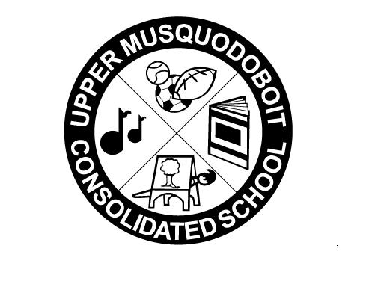
Upper Musquodoboit Consolidated School
Sunday | Monday | Tuesday | Wednesday | Thursday | Friday | Saturday
 | Phys. Ed P-6 | Music | Library | Phys. Ed. P-6 | Music
1 | 2 | 3 | 4 | 5 | 6 | 7
 | Truth & Reconciliation Day  No Classes | RWM Grade 6  Assessments  Garlic Fingers | Grilled Cheese | World Teacher Day  RWM Grade 6  Assessments | Pepperoni Pizza
8 | 9 No Classes | 10 | 11 | 12 | 13 | 14
 | 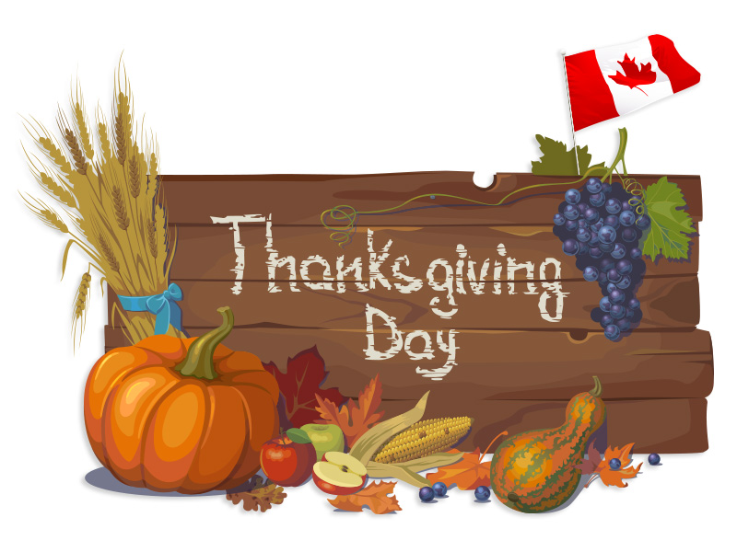 | SAC Meeting  2pm  Garlic Fingers  Garlic Fingers | PHOTO DAY  RWM Grade 6  Assessments  Spaghetti & Meatballs |  | Bus Evacuation Day  RWM Grade 6  Assessments  Pepperoni Pizza
15 | 16 | 17 | 18 | 19 | 20 | 21
 | Bus Evacuation Rain Date | Garlic Fingers | Tacos |  | Pepperoni Pizza
22 | 23 | 24 | 25 | 26 | 27 | 28
 | Say the ABC’s in a spooky voice!  Tell a story that begins with “When I was little….  National Cat Day!  How many words can you rhyme with cat?  Halloween Costume Day  Pepperoni or Cheese Pizza | Garlic Fingers | Pancakes |  | Professional Development  No Classes
29 | 30 | 31 Wear  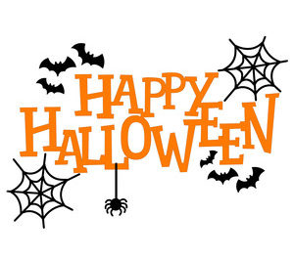  Orange & Black Garlic Fingers

