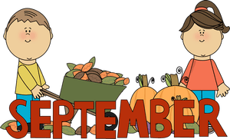 | 2023

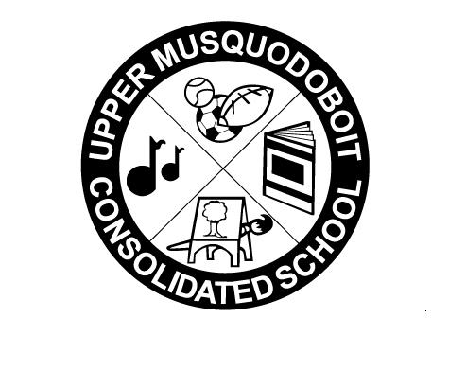
Upper Musquodoboit Consolidated School
Sunday | Monday  Phys. Ed  P-6. | Tuesday  Music | Wednesday  Library | Thursday  Phys. Ed.  P-6 | Friday  Music | Saturday
 |  |  |  | 7 | 8 | 9
 |  |  |  | Welcome
10 | 11 | 12 | 13 | 14 | 15 | 16
 |  | Garlic Fingers |  | Anti-Bullying Day  Wear Pink | Pepperoni Pizza
17 | 18 | 19 | 20 | 21 | 22 | 23
 |  | Garlic Fingers |  | Curriculum Night  6:00 – 7:00 pm | Terry Fox Run -pm  Pepperoni Pizza
24 | 25 | 26 | 27 | 28 | 29 | 30
 |  | Garlic Fingers |  |  | Orange Shirt Day  Pepperoni Pizza

