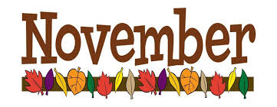 | 2023

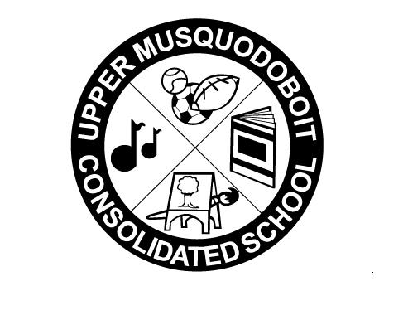
Upper Musquodoboit Consolidated School
 | Sunday | Monday |  | Tuesday | Wednesday | Thursday | Friday | Saturday
 |  | Phys. Ed. |  | Music | Library | Phys. Ed. | Music
 |  |  |  |  | 1 | 2 | 3 | 4
 |  |  |  | Garlic Fingers | “Wall of Honour” pictures due  Chicken Burgers |  | Pepperoni Pizza
 | 5 | 6 |  | 7 | 8 | 9 | 10 | 11
 | Clocks  “Fall Back”  1 Hour |  |  | Garlic Fingers | G  Cheese Omelet  Cheese omelet |  | Remembrance Day  Service-12:45  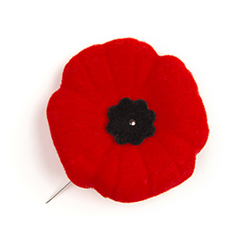  “We will remember.”  Pepperoni Pizza | Remembrance Day
 | 12 | 13 |  | 14 | 15 | 16 | 17 | 18
 |  | No Classes | SAC Meeting  2PM  Garlic Fingers |  | Caesar Salad & Garlic Toast |  | Assessment & Evaluation Day  NO STUDENTS PRESENT
 | 19 | 20 |  | 21 | 22 | 23 | 24 | 25
 |  |  |  | Garlic Fingers | Chicken Pot Pie | PD Day-AM  Parent Teacher-PM  1-3  5:30-7:30  No Classes | Pepperoni Pizza
26 |  | 27 | 28 |  | 29 | 30 | 1 | 2
 |  |  |  | Garlic Fingers | Potato Wedges/Gravy |  | Pepperoni Pizza

