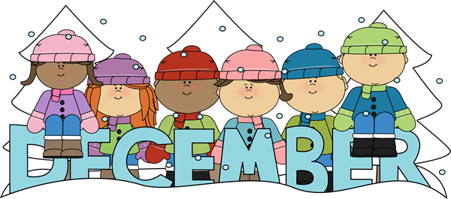 | 2023

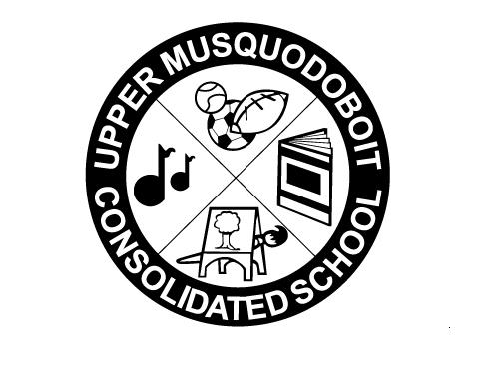
Upper Musquodoboit Consolidated School
Sunday | Monday | Tuesday | Wednesday | Thursday | Friday | Saturday
 | Phys. Ed. P-6 | Music/Fiddle | Library | Phys. Ed. P-6 | Music
3 | 4 | 5 | 6 | 7 | 8 | 9
 | PD Day  No Classes | Garlic Fingers | Grinch Cheese  Quesadillas  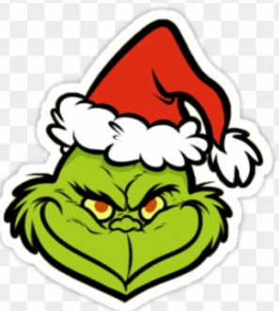 |  | Pizza  Pizza
10 | 11 | 12 | 13 | 14 | 15 | 16
 |  | Christmas Concert  12:45pm  6:30pm  Garlic Fingers  Garlic Fingers | Reindeer Sloppy Joes  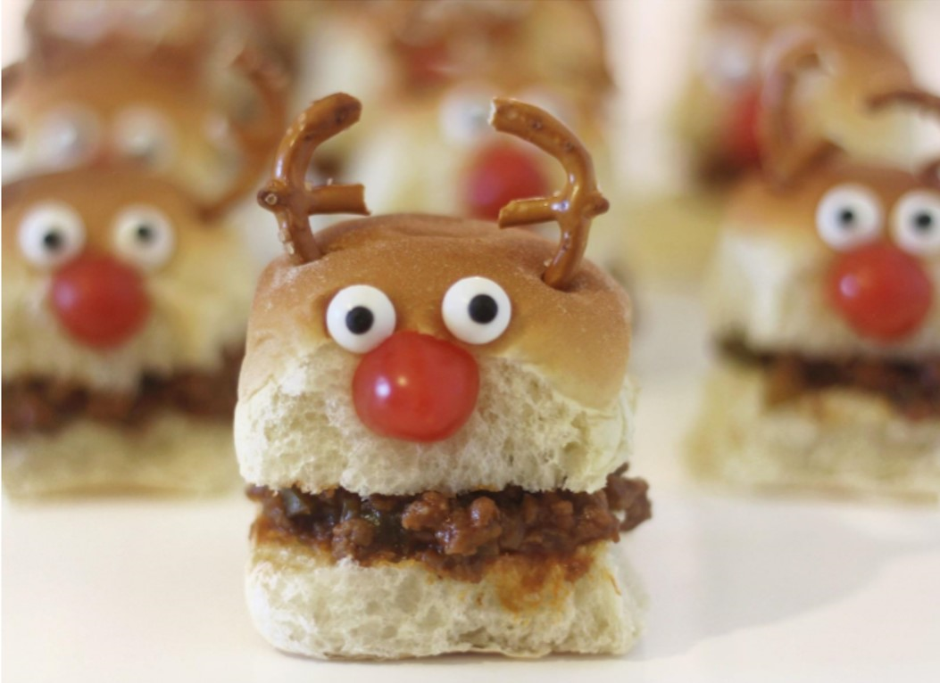 |  | Pizza
17 | 18 | 19 | 20 | 21 | 22 | 23
 | Ugly Sweater Day  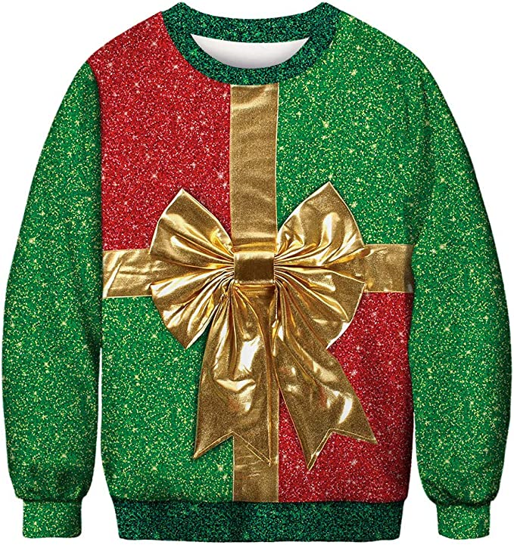  Bazaar | Red/Green Day  Turkey Dinner  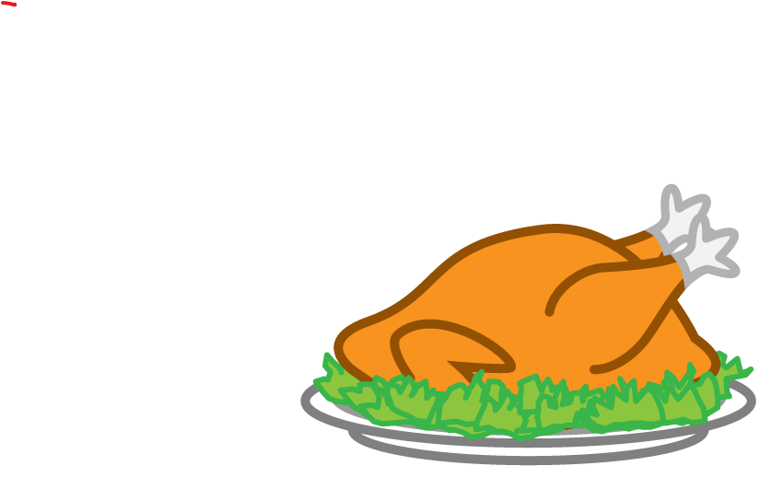 | 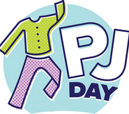 | Christmas Break
24 | 25 | 26 | 27 | 28 | 29 | 30
 | Christmas Day |  | Christmas Break  Classes Resume on Tuesday, January 2, 2024

Hot Lunch will resume on Friday, January 5th.

