2024

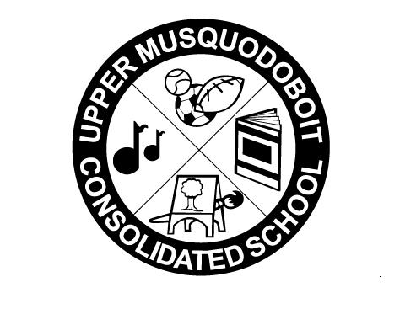
Upper Musquodoboit Consolidated School
Sunday | Monday | Tuesday | Wednesday | Thursday | Friday | Saturday
 | Phys. Ed. P-6 | Music/Fiddle | Library/Band | Phys. Ed. P-6 | Music
 | 5 | 6 | 7 | 8 | 9 | 10
 | SAC Meeting-2pm | Garlic Fingers | Spaghetti & Meatballs |  | Pepperoni Pizza
11 | 12 | 13 | 14 | 15 | 16 | 17
 |  | Garlic Fingers | Chicken Caesar Wraps |  | 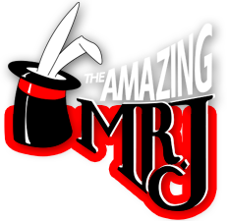  Magic Show  Pepperoni Pizza  Pepperoni Pizza
18 | 19 | 20 | 21 | 22 | 23 | 24
 | Heritage Day  No Classes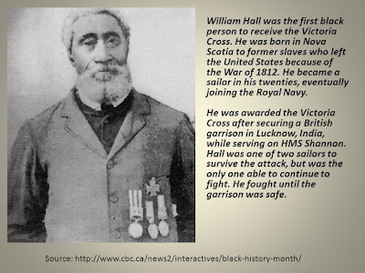 lasses | Garlic Fingers | Tacos |  | Pepperoni Pizza
25 | 26 | 27  Garlic Fingers | 28  Turkey Soup | 29 | 1  Pepperoni Pizza | 2
 | February is Registration Month

