2024

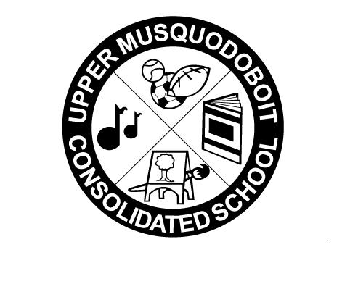
Upper Musquodoboit Consolidated School
Sunday | Monday  Phys. Ed. | Tuesday  Music/Fiddle | Wednesday  Library/Band | Thursday  Phys. Ed. | Friday  Music | Saturday
 | 1 | 2 | 3 | 4 | 5 | 6
 | 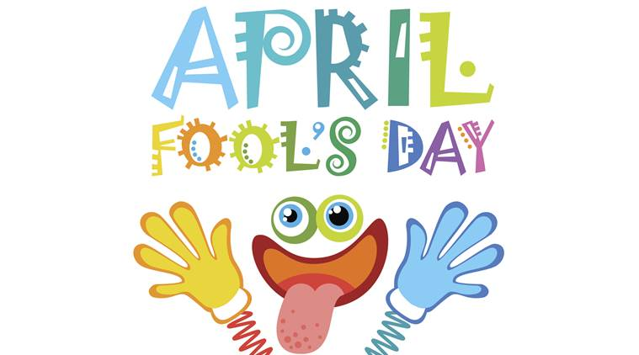  No Classes  Easter Monday | 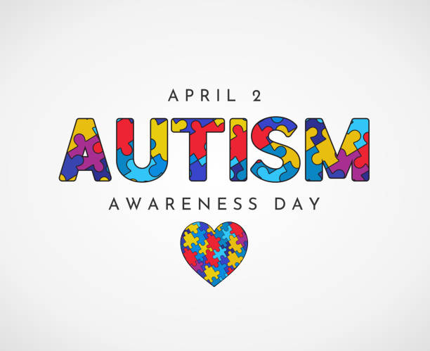  Garlic Fingers | Nachos & Cheese | AM-PD Day  PM- Parent Teacher  1-3pm  5:30 – 7:30  No Classes | Pepperoni Pizza  Pizza
7 | 8 | 9 | 10 | 11 | 12 | 13
 |  | SAC Meeting  2pm  Garlic Fingers | SUBWAY 6” Sub  Coldcut or Turkey |  | Pepperoni Pizza  Pizza
14 | 15 | 16 | 17 | 18 | 19 | 20
 |  | Garlic Fingers | Egg & Cheese English Muffin |  | Pepperoni Pizza
21 | 22 | 23  Garlic Fingers | 24 | 25 | 26 | 27
 |  |  | Pancakes |  | Pepperoni Pizza
28 | 29 | 30  Garlic Fingers

